BUSINESS AND PLANNING ACT 2020 | 

APPLICATION FOR THE GRANT OF A PAVEMENT LICENCE

APPLICANT DETAILS – if applying on behalf of applicant please complete agent box in addition
Title: | First name(s): Wagamama Limited |  | Surname: Wagamama Limited
Postal Address:
5-7 Marshalsea Road
Post Town: London |  | Post Code: SE1 1EP
Phone (Home): 02038597752 |  | Phone (Mobile): 07570340645
e-mail address: t.harvey@popall.co.uk
Date of Birth: |  | National Insurance number:

AGENT DETAILS
Title: Mr | First name(s): Thomas |  | Surname: Harvey
Postal Address:
Poppleston Allen
The Stanley Building
7 Pancras Square
Post Town: London |  | Post Code: N1C 4AG
Phone (Home): 02038597752 |  | Phone (Mobile): 07570340645
e-mail address: t.harvey@popall.co.uk

BUSINESS PREMISES DETAILS
Trading Name:
Wagamama
Postal Address:
Unit Sug Norris Road Staines-upon-Thames TW18 4UP

Registered Office address (if limited company and different to the postal address):
5-7 Marshalsea Road, London, England, SE1 1EP

Company Registration Number:  02605751 | Telephone number:  02038597752  Email address:  t.harvey@popall.co.uk
What is your interest in the premises? Please detail below and attach details of the lease, tenancy or other arrangement:
As existing.
Which of the following is the above premises used for? (please tick one of the following options)
Use as a public house, wine bar or other drinking establishment
Other use for the sale of food or drink for consumption on or off the premises (the premises does not hold a Premises Licence to carry out licensable activity under the Licensing Act 2003)  Please note that if you are not licensed for the sale of alcohol this licence does not give you permission to do so. |  | Yes – 16/00114/LAPRE
Both of the above uses:

Please quote premises licence number

AREA OF HIGHWAY PROPOSED TO BE USED
Please note you are required to submit a scale plan of this area with your application. We will expect the plan to show:
- Proposed area covered by licence in relation to highway. Please show the width of the existing footway with measurements clearly shown.
- Position and number of proposed tables and chairs, together with any other items that you wish to place on highway.
- How you are going to mark the boundary of where your furniture ends.
- Clear measurements of:
- The pathway width and length (for example from the building boundary to the kerbside)
- Building width of the premises
- The dimensions of the area to be taken up by the objects to be places on the highway
- Dimensions of street furniture already in place in front of the premises e.g. lamp posts, signs, bins etc. If such features exist please indicate their position on plan.
Example of plan required showing the area requested and street fixtures:
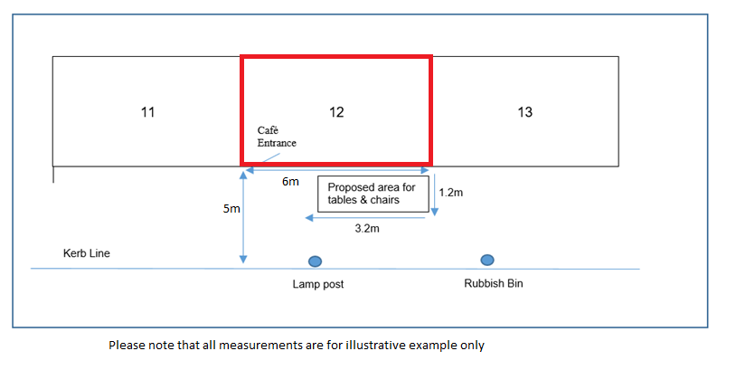
Please provide a description of the area of the highway to which this application relates, together with how you propose to mark the boundary of the furniture:

As existing. Attached with application.

RELEVANT PURPOSE THE APPLICATION RELATES TO:
Which of the following relevant purposes do you wish to put furniture on the highway for?
(please tick one of the following options)
To sell or serve food or drink supplied from, or in connection with relevant use of, the premises (food sales table/counter outside)
For the purpose of consuming food or drink supplied from, or in connection with relevant use of, the premises
Both of the above purposes | Yes

DAYS AND TIMES
During what times do you propose to place furniture on the highway on each of the following days:
Please use the 24hr clock. The hours you apply for will not necessarily be granted as this is considered on a case by case basis.
Mondays | 08.00-23.00 | Fridays | 08.00-23.00
Tuesdays | 08.00-23.00 | Saturdays | 08.00-23.00
Wednesdays | 08.00-23.00 | Sundays | 08.00-23.00
Thursdays | 08.00-23.00

FURNITURE TO BE PLACED ON THE HIGHWAY
Please provide a description of the furniture you propose to place on the highway. (Numbers, dimensions, material and type)
(Please note you are required to provide photographs or brochures of the proposed furniture with your application)

As existing. 3 Barrier(s) 12 Chairs 3 Table(s) 1 Planter.

Please detail the quantity you intend to place on the highway:
Items to be placed on highway: | Number:
Tables | 3
Chairs | 12
Benches
Barriers | 3
Umbrellas
Food Counters
Planters | 1
Other furniture, please describe

Please detail where furniture will be stored when not in use:

Inside the premises.

Additional information:
Please provide any additional information which is required or relevant to your application:

Please use this part of the form to check that your application is complete. If the answer to any of these questions is no, then your application is incomplete and should not be sent:
Checklist: | Yes or no:
Have you completed all relevant parts of the form? | Yes
Have you paid the fee? | Yes
Has the form been signed? | Yes
Have you included the plan of the proposed area?  A plan showing the location of the premises shown by a red line, so the application site can be clearly identified.  A plan clearly showing the proposed area covered by the licence in relation to the highway, if not to scale, with measurements clearly shown. The plan must show the positions and number of the proposed tables and chairs, together with any other items that they wish to place on the highway. The plan shall include clear measurements of, for example, pathway width/length, building width and any other fixed item in the proposed area. | Yes
Have you included evidence of identity and right to work?
Have you included your risk assessment?

DATE OF APPLICATION AND SITE NOTICE
Please state the date that this application for a Pavement Licence is being submitted | 11th September 2026
Site Notice- an applicant for a pavement licence must on the day the application is made, fix a notice of the application to the premises so that the notice is readily visible to, and can be read easily by, members of the public who are not on the premises. The notice must be constructed and secured so that it remains in place until the end of the public consultation period. Evidence of the site notice requirement must be supplied to the Council.  Please confirm what date the notice went on display: | Yes – 11th September 2026

DECLARATIONS BY APPLICANT
I understand that I am required to give notice of my application in accordance with the requirements of the Business and Planning Act 2020 and that failing to do so will lead to the revocation of any licence granted.
I understand I must hold and maintain public liability insurance up to a value of £10 million. Evidence of which must be provided before the licence will be issued.
I confirm that I have the right to occupy the premises specified in this application form.
I understand my application will not be considered to be complete until all the required documents and information have been provided and the application fee has been paid.
I understand that the application fee paid is non-refundable if my application is refused or if any licence granted is subsequently surrendered or revoked.
I understand that the Authority is under a duty to protect the public funds it administers, and to this end may use the information I have provided on this form for the prevention and detection of fraud. I understand that it may also share this information with other bodies responsible for auditing or administering public funds for these purposes.
I declare that the information given above is true to the best of my knowledge and that I have not wilfully omitted any necessary material. I understand that if there are any wilful omissions, or incorrect statements made, my application may be refused without further consideration or, if a licence has been issued, it may be liable to revocation.
I understand that the Authority is collecting my data for the purposes described on this form and will not be used for any other purpose, or passed on to any other body, except as required by law, without my consent.
I acknowledge that the Authority’s published standard conditions as detailed in the Pavement Licence policy online will be attached to my Pavement licence, together with any conditions that the Secretary of State dictates as mandatory. There may also be non-standard conditions which are added to the licence which the Authority deems reasonable.
Signature:

Print Name: Poppleston Allen Solicitors

Date: 11th September 2026

GUIDANCE Notes

Please return this form with all relevant documents and proof that the application fee has been paid to:
licensing@spelthorne.gov.uk

Should you have any questions in relation to this application please contact the Licensing Team.

